
IW-14
YEAR 7 SCIENCE
EARTH & SPACE SCIENCES (MODIFIED)
TEST 1 - THE EARTH AND MOON

NAME: CLASS: Mark: 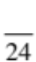

Achievement standards being tested
Predictable phenomena on Earth, including seasons and eclipses, are caused by the relative positions of the Sun, Earth and the Moon.

Mark | ND | NW | C | HC | O
Mark Range | 0-4 | 5-9 | 10-13 | 14-17 | 18-24

Multiple Choice Write the answer to each question in the appropriate box at right.

1. The main cause of day and night is:
QUESTION | ANSWER
1
2
3
4
5
6
7

A rotation of the Earth.
B revolution of the Earth.
C orbit of the Earth.
D the tilt of the Earth on its axis.

2. The diagram below relates to which season in Australia?
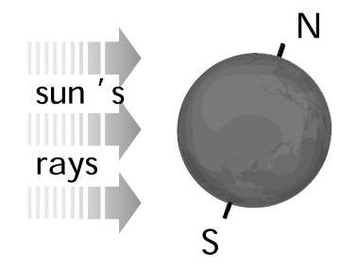
A Winter
B Spring
C Summer
D Autumn

3. The moon, stars, planets and the sun all rise in the:

A west.
B north.
C south.
D east.

4. The different shapes of the moon as seen from Earth are called:

A stages.
B phases.
C fractions.
D crescents.

5. The time taken for the Moon to orbit the Earth once is closest to:

A 24 hours.
B 14 days.
C 27 days.
D 365 days.

6. Which of these has the greatest effect on the tides on Earth?

A Mars
B Venus
C The Moon
D The Sun

7. In which months does Australia have winter?

A December, January, February.
B March, April, May.
C June, July, August.
D September, October, November.

Short Answer Write the answer to the questions in the spaces provided.

1. Complete the following sentences using the following words.
orbiting, rotation, tides, Moon, tilted, 23.5°, Northern, Southern, gravitational, Hemispheres, spinning, orbit, equator, leap.

(a) Sunrise and sunset are caused by the Earth’s .

(b) The Earth takes 1 year to the sun once. The orbit is

actually 365.24 days in length, which is why most years have 365 days and a

year has 366 days.

(c) The gravitational pull from the moon causes .

(d) A solar eclipse is caused when light from the sun is blocked by the .

(e) The seasons are caused by the Earth the Sun and being

at an angle of approximately .

(f) Day and night are caused by the Earth on its axis.

(g) The top and bottom halves of the Earth are called the and

.

(h) The imaginary line around the middle of the Earth is called the .

(i) The pull of the moon is one-sixth that of the Earth.

(7)

2. Sketch the shape of:

(a) a crescent moon

(b) a gibbous moon

(c) a full moon.

(3)

3. On the diagram below, label where a full moon, new moon , the first-quarter and
third- quarter moons occur.
(2)

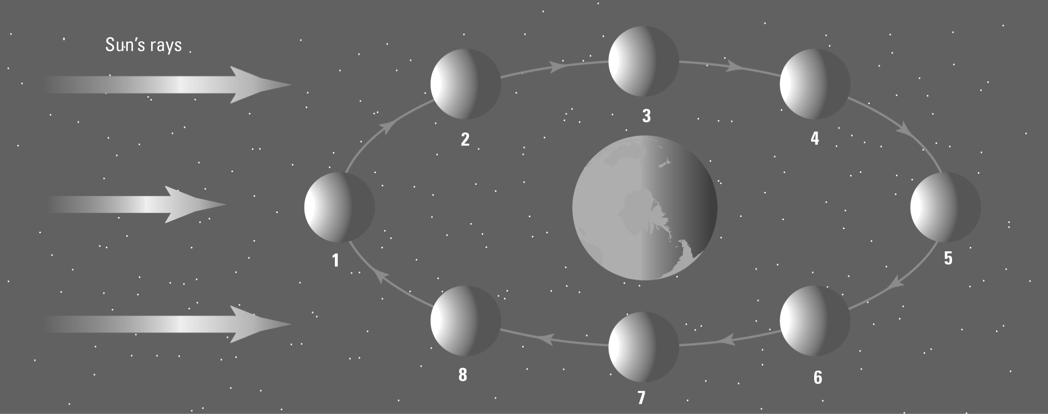

4. Identify which of the pictures below represents summer in Australia and which represents winter.

A 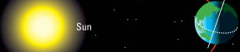 B 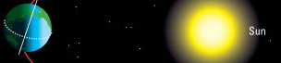

(1)
5. Look at the diagram below.

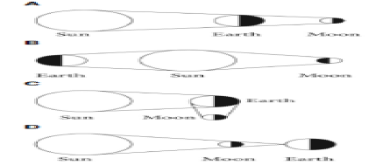

(a) Is this a lunar eclipse or a solar eclipse? (1)

(b) Explain why you chose this answer.

(1)

6. In the diagram below, show whether points A, B, C and D are examples of high tide or low tide.

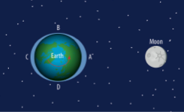

A: B:

C: D: (2)

